Mongo DB Attributes v2

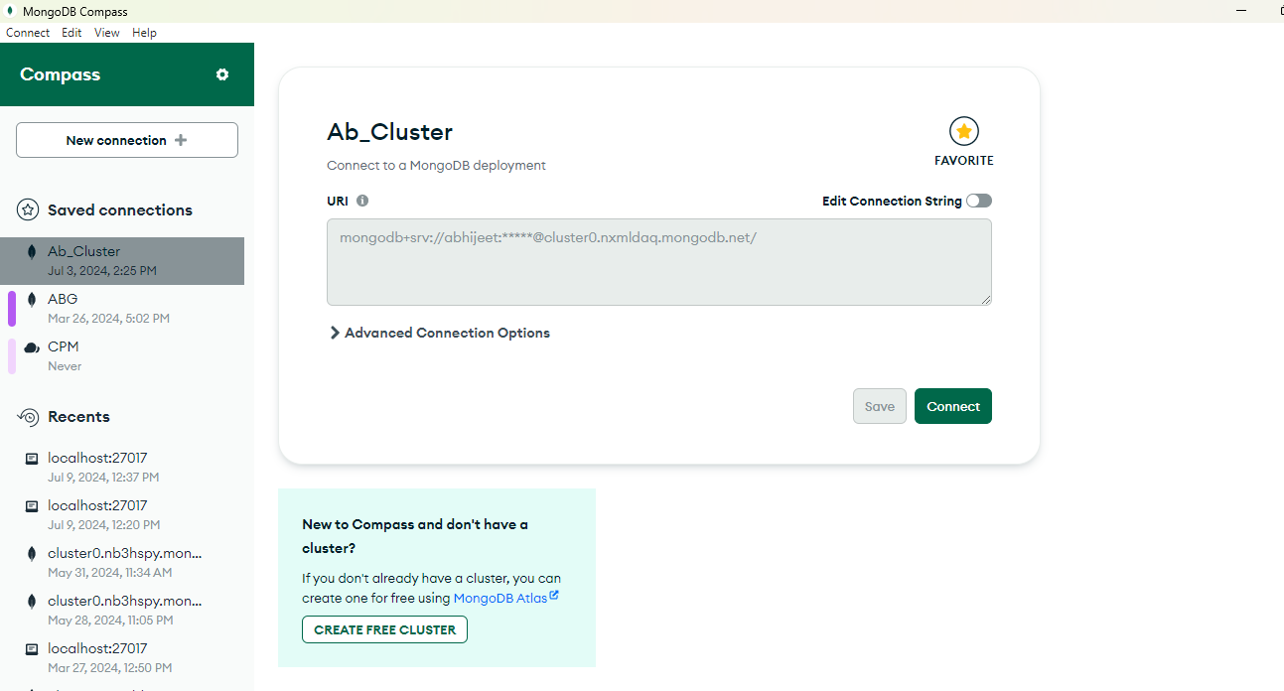

Password admin

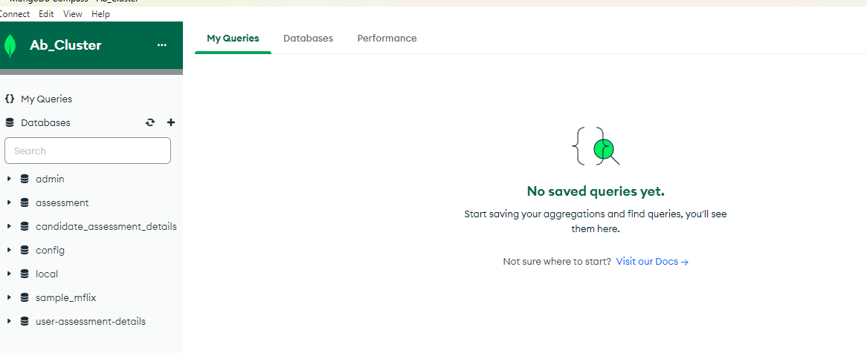

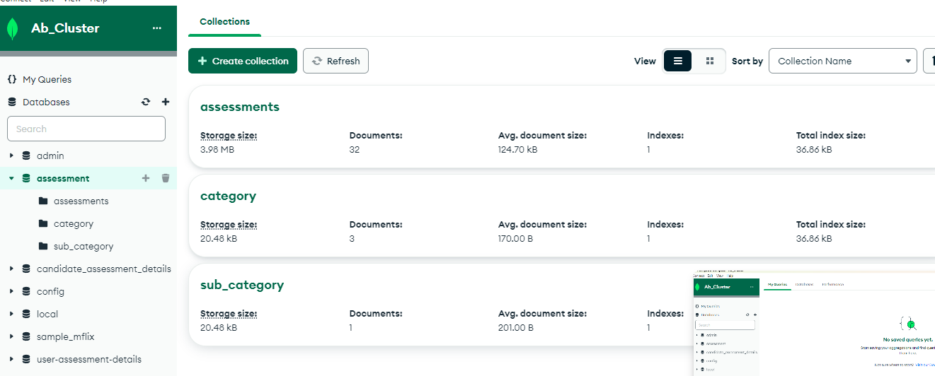

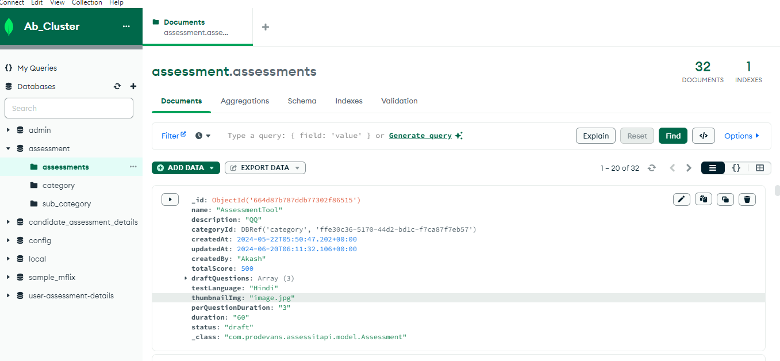

{

"_id": {

"$oid": "664d87b787ddb77302f86515"

},

"name": "AssessmentTool",

"description": "QQ",

"categoryId": {

"$ref": "category",

"$id": "ffe30c36-5170-44d2-bd1c-f7ca87f7eb57"

},

"createdAt": {

"$date": "2024-05-22T05:50:47.202Z"

},

"updatedAt": {

"$date": "2024-06-20T06:11:32.106Z"

},

"createdBy": "Akash",

"totalScore": 500,

"draftQuestions": [

{

"questionId": "AQT-RgR!bz",

"subcategoryId": {

"$ref": "sub_category",

"$id": {

"$oid": "663b1b5063027d7a5be9a1f1"

}

},

"question": "fkgkhhkir",

"questionType": "textual",

"options": [

{

"option": "folk",

"weightage": 1.5

}

],

"answer": [

"java"

],

"multipleChoice": true,

"totalWeightage": 1.5,

"createdAt": {

"$date": "2024-06-20T06:11:32.106Z"

},

"updatedAt": {

"$date": "2024-06-20T06:11:32.118Z"

}

},

{

"questionId": "AQ-v4LYis",

"subcategoryId": {

"$ref": "sub_category",

"$id": {

"$oid": "663b1b5063027d7a5be9a1f1"

}

},

"question": "Enter Question1",

"questionType": "true-false",

"options": [

{

"option": "Yes",

"weightage": 0

}

],

"answer": [

"Yes"

],

"multipleChoice": false,

"totalWeightage": 1,

"createdAt": {

"$date": "2024-06-20T06:11:32.106Z"

},

"updatedAt": {

"$date": "2024-06-20T06:11:32.118Z"

}

},

{

"questionId": "AQ-k@Shdt",

"subcategoryId": {

"$ref": "sub_category",

"$id": {

"$oid": "663b1b5063027d7a5be9a1f1"

}

},

"question": "What is color of moon?",

"questionType": "textual",

"options": [

{

"option": "",

"weightage": 0

}

],

"answer": [

""

],

"multipleChoice": false,

"totalWeightage": 0,

"createdAt": {

"$date": "2024-06-20T06:11:32.106Z"

},

"updatedAt": {

"$date": "2024-06-20T06:11:32.121Z"

}

}

],

"testLanguage": "Hindi",

"thumbnailImg": "image.jpg",

"perQuestionDuration": "3",

"duration": "60",

"status": "draft",

"_class": "com.prodevans.assessitapi.model.Assessment"

}

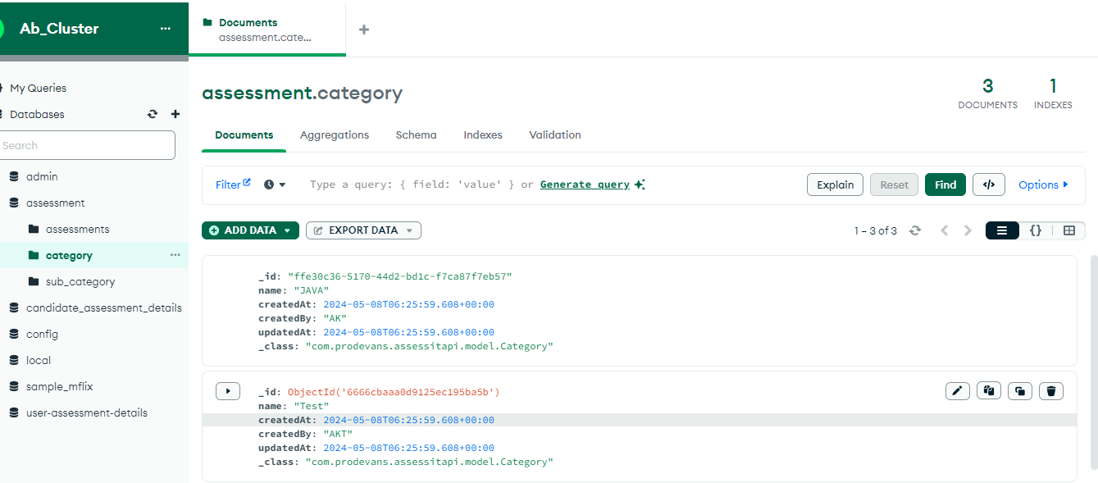

{

"_id": "ffe30c36-5170-44d2-bd1c-f7ca87f7eb57",

"name": "JAVA",

"createdAt": {

"$date": "2024-05-08T06:25:59.608Z"

},

"createdBy": "AK",

"updatedAt": {

"$date": "2024-05-08T06:25:59.608Z"

},

"_class": "com.prodevans.assessitapi.model.Category"

}

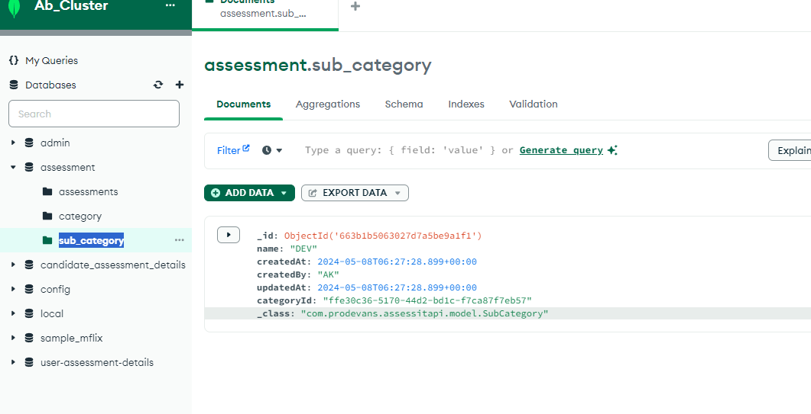

{

"_id": {

"$oid": "663b1b5063027d7a5be9a1f1"

},

"name": "DEV",

"createdAt": {

"$date": "2024-05-08T06:27:28.899Z"

},

"createdBy": "AK",

"updatedAt": {

"$date": "2024-05-08T06:27:28.899Z"

},

"categoryId": "ffe30c36-5170-44d2-bd1c-f7ca87f7eb57",

"_class": "com.prodevans.assessitapi.model.SubCategory"

}

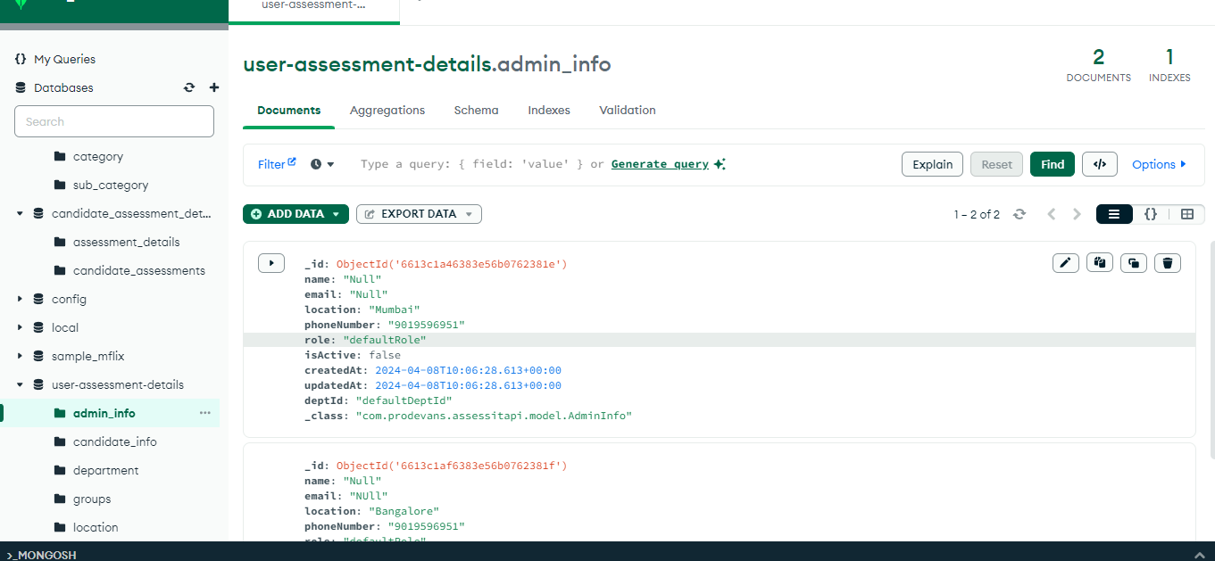

{

"_id": {

"$oid": "6613c1a46383e56b0762381e"

},

"name": "Null",

"email": "Null",

"location": "Mumbai",

"phoneNumber": "9019596951",

"role": "defaultRole",

"isActive": false,

"createdAt": {

"$date": "2024-04-08T10:06:28.613Z"

},

"updatedAt": {

"$date": "2024-04-08T10:06:28.613Z"

},

"deptId": "defaultDeptId",

"_class": "com.prodevans.assessitapi.model.AdminInfo"

}

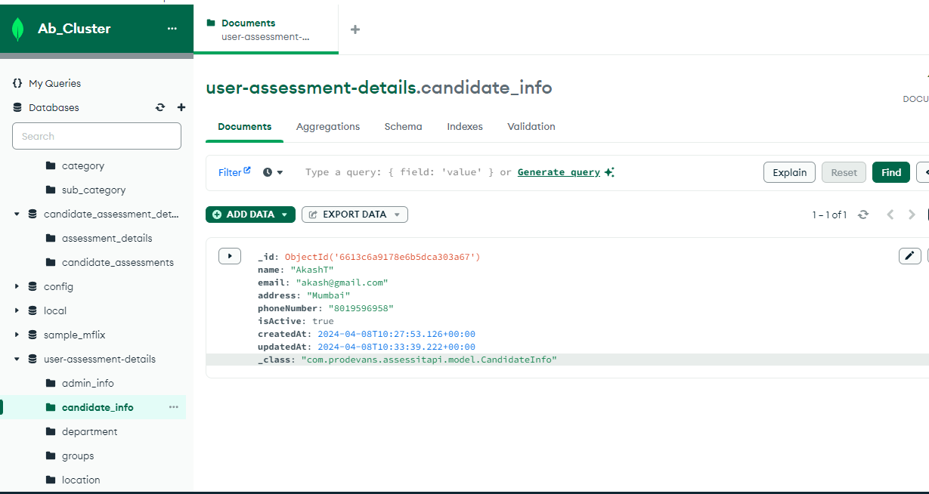

{

"_id": {

"$oid": "6613c6a9178e6b5dca303a67"

},

"name": "AkashT",

"email": "akash@gmail.com",

"address": "Mumbai",

"phoneNumber": "8019596958",

"isActive": true,

"createdAt": {

"$date": "2024-04-08T10:27:53.126Z"

},

"updatedAt": {

"$date": "2024-04-08T10:33:39.222Z"

},

"_class": "com.prodevans.assessitapi.model.CandidateInfo"

}

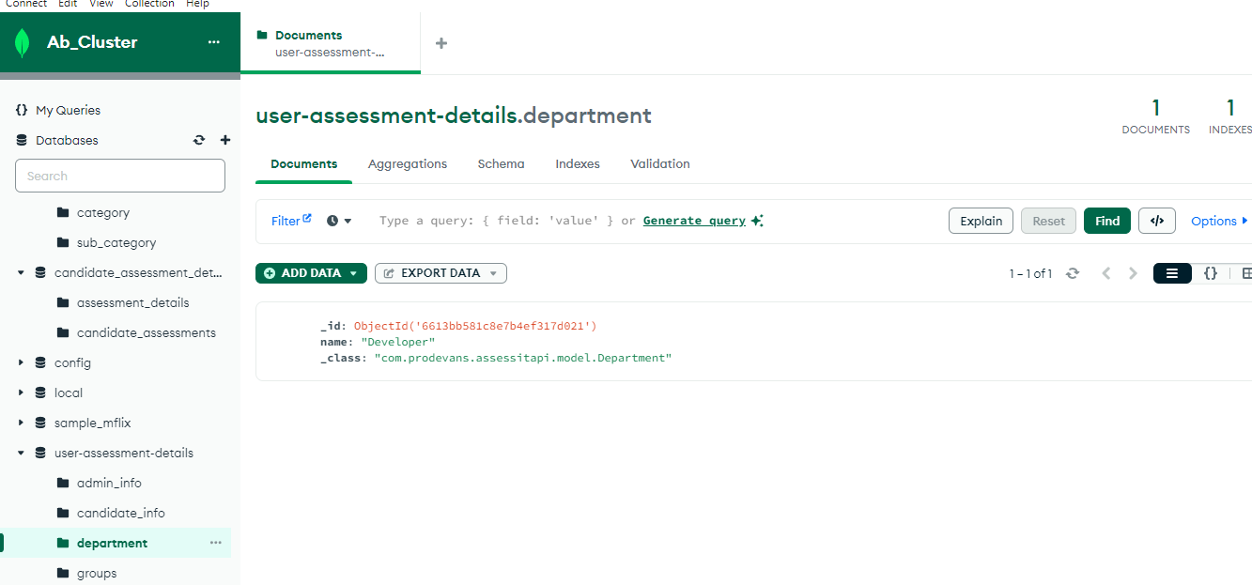

{

"_id": {

"$oid": "6613bb581c8e7b4ef317d021"

},

"name": "Developer",

"_class": "com.prodevans.assessitapi.model.Department"

}

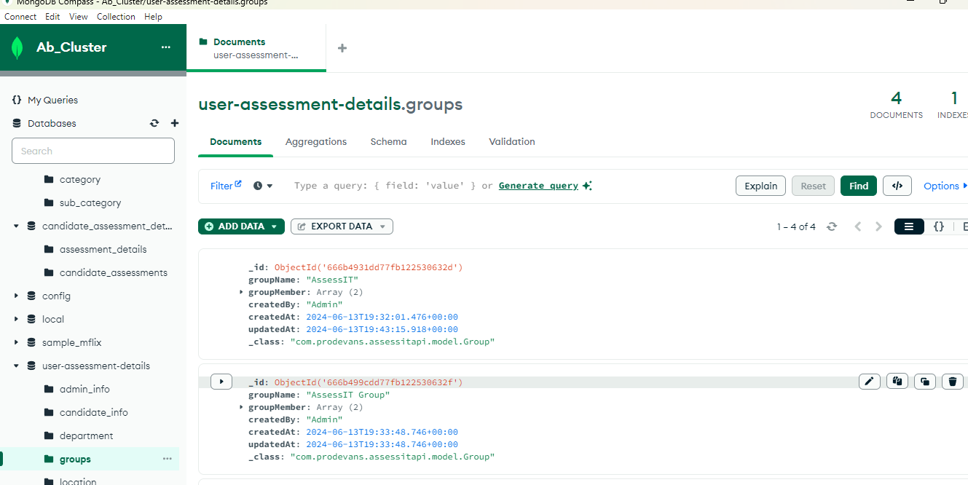

{

"_id": {

"$oid": "666b4931dd77fb122530632d"

},

"groupName": "AssessIT",

"groupMember": [

{

"candidateId": "1",

"candidateName": "Akash"

},

{

"candidateId": "2",

"candidateName": "Thakur"

}

],

"createdBy": "Admin",

"createdAt": {

"$date": "2024-06-13T19:32:01.476Z"

},

"updatedAt": {

"$date": "2024-06-13T19:43:15.918Z"

},

"_class": "com.prodevans.assessitapi.model.Group"

}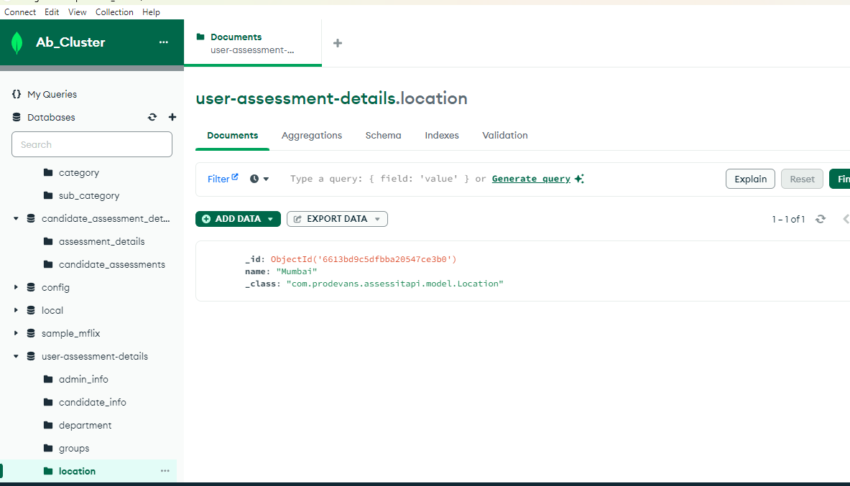

{

"_id": {

"$oid": "6613bd9c5dfbba20547ce3b0"

},

"name": "Mumbai",

"_class": "com.prodevans.assessitapi.model.Location"

}